Tab 1

ThinkTank Oceanus


Standard Operating Procedures

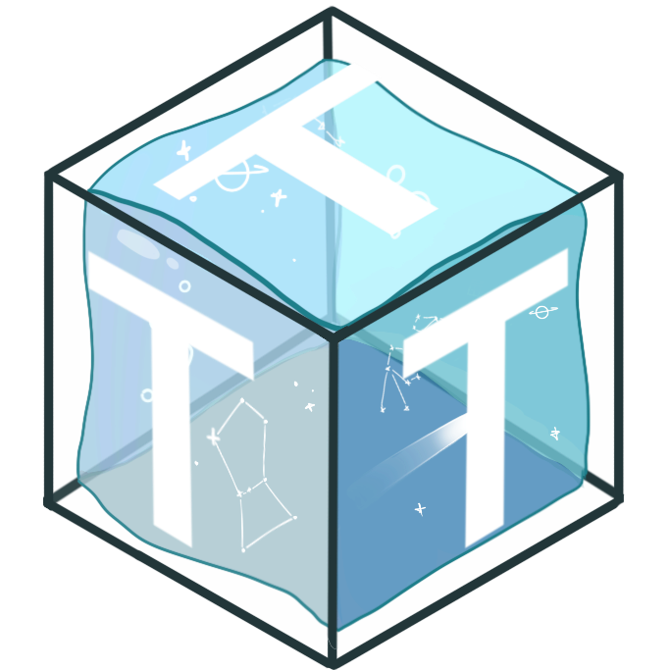

Oceanus Code of Conduct
1. Attendance & Communication
- Absence Notification: Notify the team at least 3 hours before a scheduled meeting or work session if you cannot attend.
- Meeting Commitment: Attend weekly meetings regularly; missing occasionally is acceptable, but showing up “more often than not” is the standard.
- Dropping the Project: If you decide to step away from the team, you must notify Emily, Zack, and Arjun directly so responsibilities can be reassigned.
- Communication Platform: All project-related communication must go through Discord to ensure consistency and transparency.

2. Respect & Professionalism
- Treat all team members with respect, regardless of role, skill level, or background.
- Listen actively and allow others to contribute without interruption.
- Maintain a positive and solution-focused attitude during challenges.

3. Responsibility & Contribution
- Follow Through: Complete tasks you commit to or communicate if you are unable to.
- Collaboration: Support teammates when possible and share knowledge openly.
- Accountability: Own mistakes and work with the team to fix issues.
- Deliverables: All files, reports, code, and project deliverables must be uploaded and organized in the Google Drive so they are accessible to all team members.

4. Communication Standards
- Use Discord for project communication; avoid scattering information
- Respond to team messages in a timely manner (within 24 hours when possible).
- Keep communication professional. No inappropriate language, harassment.

5. Safety & Integrity
- Follow all safety protocols when working with tools, machinery, or electronics.
- Never work alone in the lab or shop without approval.
- Uphold the Aggie Code of Honor and practice academic honesty, do not lie, cheat, or steal. Always give credit where it is due.

6. Meetings & Documentation
- All team meetings must be recorded in their corresponding notebooks for accountability and future reference.
- Notes should be clear, organized, and stored in the team’s Google Drive.

7. Conflict Resolution
- Address disagreements respectfully and seek constructive solutions.
- Escalate unresolved issues to Emily, Zack, or Arjun for mediation.

Technical Standards
- All calculated values must contain an uncertainty value and confidence level.
  - If standard error =(standard deviation/$\sqrt{N}$)
    - N must be greater than or equal to 5
- (We know this is annoying to do but it scores us more points)

Naming Conventions

TMS

F&P

EPS

GNC:
ROS - Robot Operating System
SBC - Single Board Computer
OS - Operating System
IMU - Inertial Measurement Unit
SITL - Software-In-The-Loop

C&C:
Micro controller: the on board computer for the ROV, it's the “brain”.

CAD and Simulation Software
SolidWorks
ANSYS
KiCad

Languages
Python

Units
- All calculations and units will be done in SI units including but not limited to:
Meters, Liters, Kilograms, Newtons
- This includes software and CAD prototypes and designs

Documentation Expectations
Presentations
- Sub-team leads actively present
  - Unless a substitute is found and confirmed
- All team members actively answer Q&A
- Presentation to ThinkTank Officers must be Business Casual
- Presentation to Industry professionals must be Business Formal
- Follow the ThinkTank presentation template
- Ideally, the team will practice the presentation ahead of time
Engineering Subteam Notebook
- Subteams must be consistent with recording relevant discussions in their respective subteam notebook as a better guidance for future teams.
Engineering General Notebook
- Team leads must update the general engineering notebook for regular members to catch up or go back to relevant discussions.
Github
- All work done in the github should be pushed at the end of the work session
Bill of Materials
- Shipping is a B*TCH, when projecting component costs, go all the way right before you put your credit card info in to get a realistic estimate for your BOM

Advice for the future teams

Summer
- Have team members turn on cameras during online meetings
- Anything you go over during a subleads meeting is important for the whole team to hear
- This is the time to get certified at CAD and simulation software
- Outline deliverables specifically

Fall
- Ensure that upcoming members have their general membership and red badge in order to work in the FEDC space.
- Expect many team members to drop as they get accepted to other student organizations like SRT, SEC or FormulaE
- Review the past constantly
- Expect fees from shipment, tariffs, etc. to increase the value of a component by a lot.
- TMS:
  - Ensure that after a CAD component is finalized, other teammates revise such component and reflect on its interaction with other components.

Spring

Created by Zack Hobbs and Emily Bass Werner Maldonado Class of 2028

Letters to future team leads:
Emily BWM (2028): Try your best and believe in your vision. Make sure to work together and provide a positive energy to the working enviro
nment!
Zack Hobbs (2028) : Trust yourself and trust your team, y’all are smarter together than individually! This project is all about the process, not the destination.

